

**DIABETES PREDICTION USING R LANGUAGE**

SUBMITTED BY: -

**RISHAB DUNG(2K20CSUN01083)**

SUBMITTED TO: -

**MRS.ALPANA**

**ABSTRACT**

The diabetes is one of lethal diseases in the world. It is additional a inventor of various varieties of disorders foe example: coronary failure, blindness, urinary organ diseases etc. In such case the patient is required to visit a diagnostic center, to get their reports after consultation.

**TABLE OF CONTENTS**

1. INTRODUCTION
2. TECHNOLOGY USED
3. LIBRARIES USED
4. OUTPUT
5. DATASET REVIEW
6. CONCLUSION

**INTRODUCTION: -**

The diabetes is threatening a lot of people nowadays, without having a perfect cure for it. There are actually two types of diabetes, namely Type 1 and Type 2. The type 2 diabetes is commonly called as diabetes mellitus. It can be defined as a chronic condition that affects the way the body processes blood sugar (glucose). We consider the mellitus here. After deep researches we found that, that some parameters are directly responsible to for the mellitus to occur. By using the data of the people with and without diabetes, a dataset has been build. We use that dataset to classify the people who are in the risk of getting diabetes.

**TECHNOLOGY USED: -**

* We have used R language and the platform used to develop this project is R studio.
* The main purpose of designing this system is to predict the risk of diabetes.

**LIBRARIES USED: -**

* library(ggplot2)
* library(ggvis)
* library(corrplot)
* library(caTools)
* library(ROCR)

**OUTPUT: -**

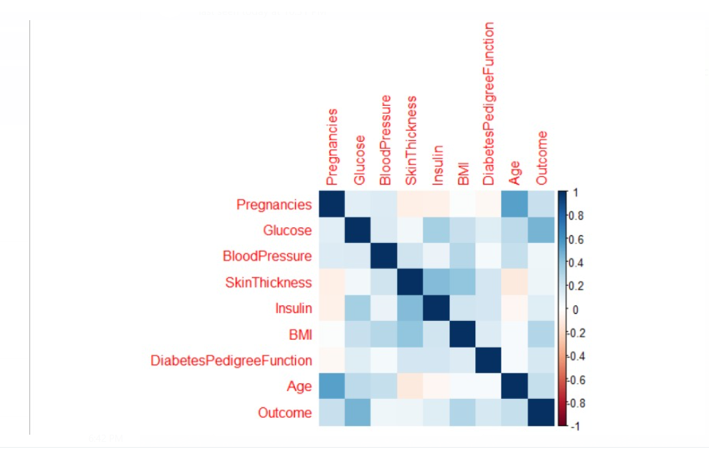

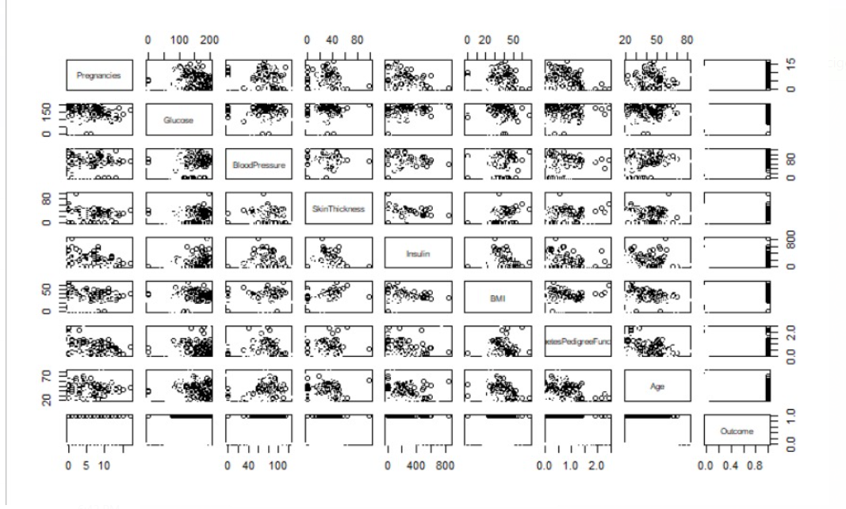

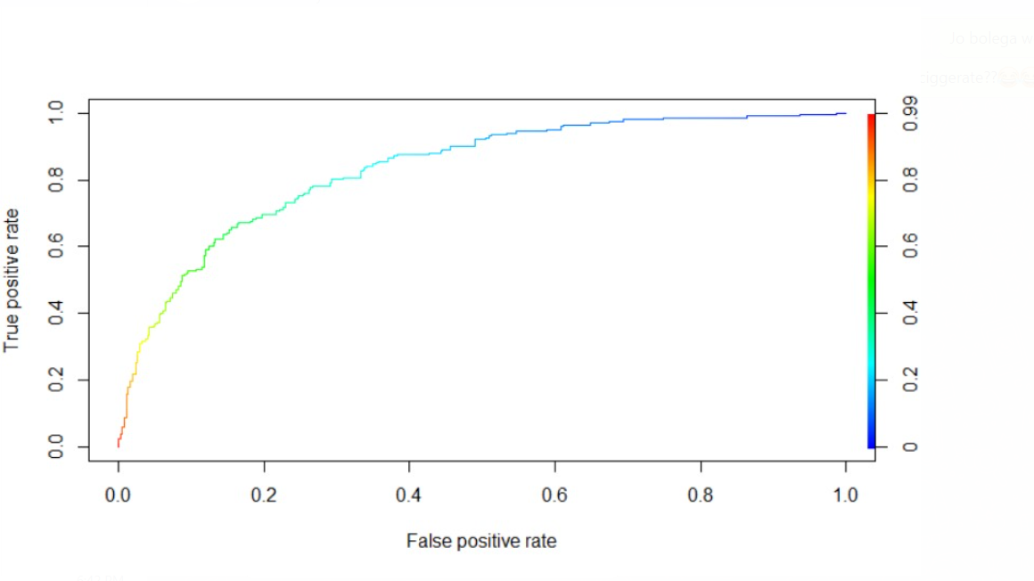

**DATASET PRIVIEW: -**

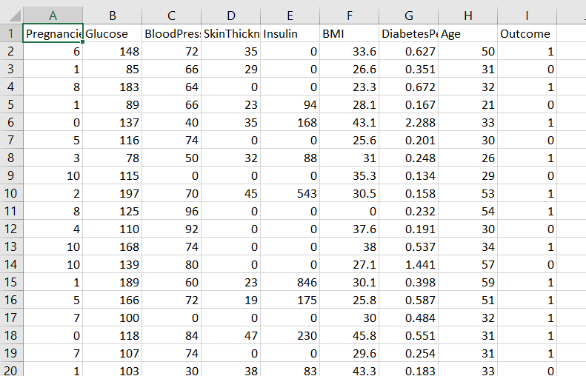

**CONCLUSION: -**

The results can be improved by applying the feature scaling and data cleaning. From this project we predict the type 2 diabetes, commonly called as diabetes mellitus. As a result, it can help to improve their health conditions.